Who Was Alice From Dallas?

by Linda Styles Berkery | 100th Bomb Group, Reflections

When I was a child, my grandfather used to take me to watch the planes take off and land at the Albany (NY) Airport. We would park on the side of the road and peer through the wire fence. “Is that Alice?” I would ask. Papa would lower his sunglasses and grunt, “There are no war planes here.” Conversation over.
I knew that Dad flew in a plane called Alice from Dallas, but it confused me that a plane could have a name. I didn’t know Dallas was a city, or Alice was real—the only Alice I knew was in Wonderland. I would later understand that Alice from Dallas, was a lot more than a clever rhyme to repeat.
Alice Madeline Jones knew Bill DeSanders at Highland Park High School in Dallas, but they didn’t date until her spring break from college in 1941. Like many young couples, Alice and Bill were listening to the radio when President Roosevelt announced the attack on Pearl Harbor. Since Bill was already taking private flying lessons, he enlisted in the Army Air Corp. Bill wanted to serve his country as a pilot. But, neither Alice, nor Bill, could possibly imagine the dangers of combat missions in the air.
Alice was in constant contact with Bill during his early training days as Bill was being evaluated for his piloting and leadership skills. After Alice finished her degree at the University of Texas, Bill proposed. They married on October 31 (Halloween) in 1942.

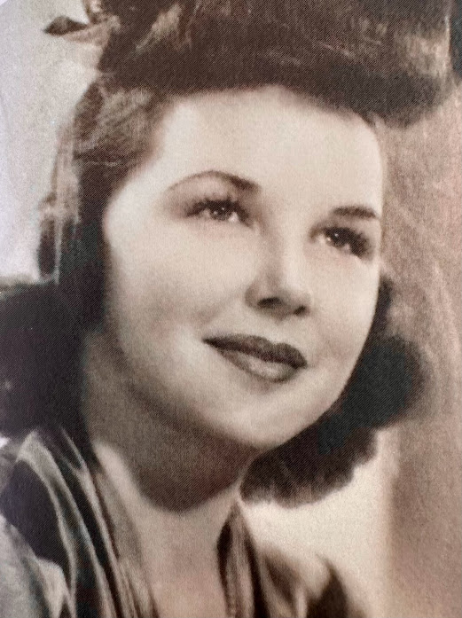Alice on her wedding day
Bill kept Alice’s photo by his bed. Keeping memories of home and the women they loved was important to all the young airmen. When the new B-17s arrived in Kearney, Nebraska in April of 1943, airmen quickly began to nickname their plane. It sure beat calling it by a number. Nicknames and nose art painted by talented members of the group kept up the morale and gave a common bond. Pilot DeSanders, of course, named plane #25867 Alice from Dallas.
Bill and Alice were together in the early parts of Bill’s training, but, it soon became clear they must separate. The 100th Bomb Group, where Bill was assigned, would be heading to England for combat missions.
Alice, the B-17 landed at the new base Thorpe Abbotts, England on June13, 1943, while the lovely Alice Jones DeSanders was back home living with her parents, expecting her first child in December.
My father, Lt. William Styles, also called Bill, was second in command of the crew of Alice from Dallas, flying as copilot with Bill DeSanders. Dad and Bill flew seven bombing missions together and they had a good relationship, which was vital to manage a B-17. Long after the war, the two Bills had a reunion in Dallas. Their bond was still intact even though each had a different war experience after July 25, 1943.
The B-17, Alice from Dallas, was not flying on July 25, 1943 and neither was Captain DeSanders. My father and the rest of the crew from Alice from Dallas were in a different plane, called Duration +6. Damaged by flak, the plane mushed into the North Sea. Six men were killed by the crash. The four survivors became prisoners of war. Flying days were over for Dad.
Those on the home front like Alice DeSanders, worried and prayed daily for their airmen. Information was spotty and late coming. Alice didn’t know about the crash on July 25th, but one month later, she heard news about her namesake plane, and was terrified.
On August 17, 1943, Alice from Dallas, exploded in a ball of fire on a bombing mission. near Belgium. Two airmen were killed in action, three were taken prisoner, and five evaded capture. Alice DeSanders didn’t know that her husband Bill was not on the plane. It would take weeks before she heard an accurate story.
A new plane became Alice from Dallas II. On February 13, 1944, Pilot Bill DeSanders along with Lt. John (Lucky) Luckadoo completed their twenty-fifth mission in the second Alice.
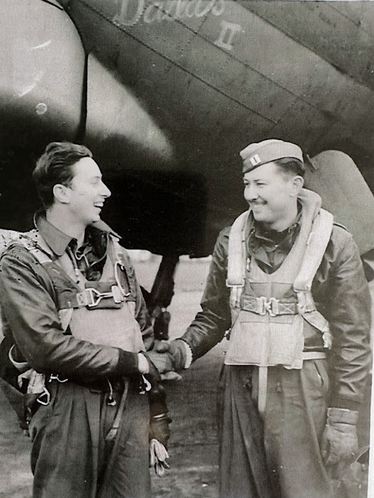Luckadoo left, DeSanders right
After returning to the English base at Thorpe Abbotts and celebrating the completion of his combat duty, Bill DeSanders came home to Dallas and Alice and held his infant daughter, Janet. (The DeSanders family would welcome another daughter, Susie, in 1945, and a son, Lee, in 1950.)
Back with his wife, Alice, Captain Bill DeSanders finally released his emotions and shared his attachment to his plane. On a photo of the B-17 DeSanders wrote: “This is Alice from Dallas II – in which I flew my last 8 missions, 6 of these were completely destroyed targets in Germany and France by formation which Alice led.”
His love, Alice, had been with him all along.
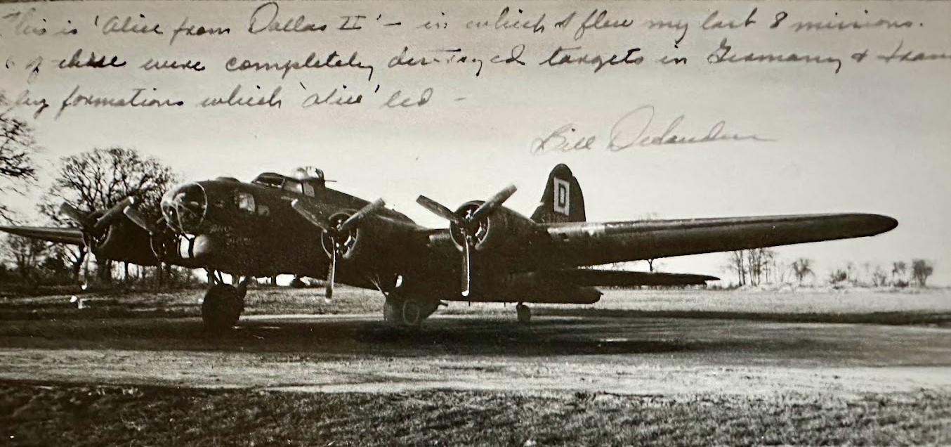Alice from Dallas II

Search

